

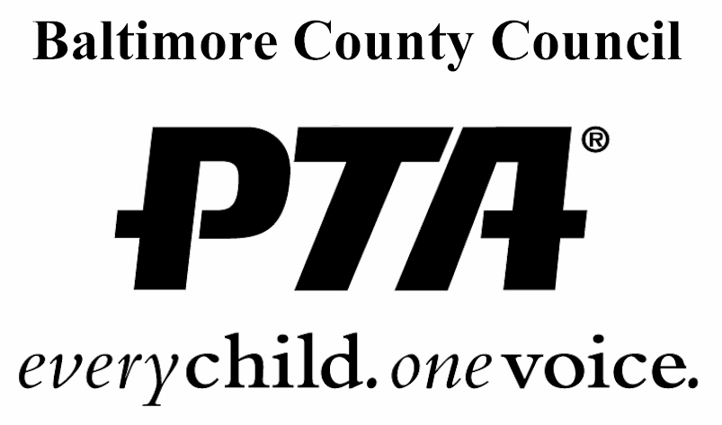



2016-2017

AWARDS PACKET

“A Night of Shining Stars”

Awards Nomination Deadline:

March 30, 2017, 11:59pm

Showcase your

PTA/PTSA Shining Stars

at the Awards Celebration

April 20, 2017

7:00 p.m.

Cockeysville Middle School



PTA Council of Baltimore County

2016-17 Awards

**“A Night of Shining Stars”**

Dear Presidents/Awards Chairpersons:

The PTA Council of Baltimore County will hold its annual awards celebration at the General Meeting on **Thursday, April 20, 2017 at 7:00 pm, Cockeysville Middle School.**

This packet contains nomination forms for the following awards:

* **Recognition Awards** – to give each PTA/PTSA the opportunity to have one of its members, parents, teachers, staff members or volunteers receive countywide recognition for doing a great job.
* Unit of Excellence Award – honors each PTA/PTSA demonstrating performance beyond the Standards of Continuing Affiliation (SoCA).
* **“Top Program” Awards** – to give each PTA/PTSA the opportunity to showcase as many as 12 of its best programs.
* **Outstanding Educator of the Year** – to give each PTA/PTSA the opportunity to obtain countywide recognition for a member of its school’s staff. **There will be one primary and one secondary Educator of the Year Award presented for the entire county**. (Note: This award is based on performance during the 2015-16 school year, not a lifetime achievement award.)

***The PTA Council Awards Committee must receive all***

***Nominations forms by March 30, 2017, 11:59pm***

Nomination forms can be sent through BCPS interschool mail to:

PTA Council of Baltimore County

Attn: Emory Young, Franklin Elementary School

**Mailed to PTA Council President:**

Emory Young

179 Carolstowne Road, Reisterstown, MD 21136-6502

**Scanned and emailed to:**

[awards@bcptacouncil.org](mailto:awards@bcptacouncil.org)

**Hand-delivered at the March 30, 2017 PTA Council General Meeting**

***A local PTA/PTSA must be a unit in “Good Standing”* in order to submit a nomination form(s) for any award. When completing the nomination forms, pay attention to the criteria and required documentation for each award, especially for the Local Unit of Excellence Award! Please keep a copy of each submitted nomination form for your records.***

***\*To be in “Good Standing” a local must be current in regards to council dues, state/national dues, bylaws, insurance, incorporation, annual audit, annual filing of IRS 990 form, and Maryland Charitable paperwork (if required), and current officer contact information (president, treasurer, and secretary) has to have been provided by the local unit.***

**Recognition Awards**

**Each local PTA/PTSA may nominate ONE individual** (parent, teacher, administrator, staff member, nurse, therapist, community volunteer, etc.) for this recognition, which is awarded at three levels:

**Certificate of Appreciation**

**Special Recognition Award**

**Distinguished Service Award**

**The PTA Council Awards Committee will determine which level of recognition is warranted.** In almost all cases, anyone nominated for recognition will be recognized.

***Certificate of Appreciation*** – awarded for outstanding service to a local PTA/PTSA.

***Special Recognition Award*** – awarded to those whose work has had a positive effect beyond the local unit (examples: membership chair whose efforts increased local membership and, in turn, county, state, and national membership; a legislative committee member whose efforts resulted in legislation affecting children across the county, state, or nation; a volunteer whose landscaping talents helped the school’s gardening club and beautified the entire community.

***Distinguished Service Award*** – awarded to those who have served in a variety of PTA/PTSA activities for a long time and have accomplished many wonderful things, or those who managed to do something truly outstanding in a very short period of time.

**EACH PTA/PTSA MAY NOMINATE ONE CANDIDATE**

##### Nominee: _____________________________________________________

**(Please print and spell name correctly)**

##### PTA/PTSA: ___________________________________________________

##### Nominated By: _______________________________ Date: ____________

##### Phone: __________________________ Email: _______________________

**Please answer the following question on separate pages attached to this form.** You may type, print, or write legibly the answer to the question. Documentation is limited to two pages.

**What extraordinary contribution to the PTA Mission, Purposes and Goals has this individual made that makes him/her an outstanding candidate for the PTA Council Recognition Award? Please be specific.**

Local Unit of Excellence Award

A Local Unit of Excellence Award honors a PTA/PTSA performing beyond the Standards of Continuing Affiliation. A local unit must meet **8 of the 12 criteria** listed below (please check).

PTA/PTSA _______________________________________________________

President’s Signature: __________________________________________Date:___________

Person Completing Form: ______________________________________________________

Phone Number: ______________________ Email: __________________________________

* **2015-16 budget adopted** by general membership (include budget & general meeting minutes)
* **Written Treasurer’s Report** submitted at each PTA/PTSA meeting (include 1 report)
* Experienced an **increase in membership**; Members 2015-16 _____ Members 2016-17_____
* **Committee Plans of Works** approved annually by PTA/PTSA Board of Directors (include 2)
* Participated in at least 1 **National PTA-sponsored program** and/or event in 2016-17, such as Reflections, or applied for National PTA Award/Grant. Participated in ____________________________ (include event flyer or copy of grant application)
* Adhered to the **3-to-1 fundraising policy** (provide supporting paperwork**)**
* **Communicated regularly with membership** (newsletters, website, Facebook; provide samples) Website address: _____________________Facebook: _______________________
* At least 2 **voting delegates** **(provide names below)** attended **PTA Council Fall Reception & Workshops**
* At least 1 **voting delegate (provide names below)** attended **January Council General Meeting**
* At least 1 **PTA/PTSA member** **(provide names below)** attended **MD PTA Convention**
* At least 2 **board members (provide names and training attended below)** participated in **PTA Training** (E-Learning (provide certificate downloadable from National PTA website); Leadership Training, PTA Council Fall Workshop Training, MDPTA Regional and/or Financial Workshops, etc.)
* **Took part in advocacy** by attending event sponsored by Board of Education, BCPS, County/State/National Government (examples: Area Education Advisory Council Meeting, Pre-Budget Hearing, County Council Meeting); provide flyer, event notice, or agenda
  + **NAME:**
  + **EVENT:**
  + **DATE AND LOCATION:**

**“Top PTA Program” Awards**

PTA Council will honor 12 outstanding PTA/PTSA-sponsored programs conducted in 2016-17. Units may submit nominations in up to 12 categories. **If submitting nominations in more than 1 category, use a separate form for each nomination.**

**BEST MEMBERSHIP THEME OR CAMPAIGN**

**BEST READING PROGRAM**

**BEST MALE INVOLVEMENT PROGRAM**

**BEST STUDENT RECOGNITION PROGRAM**

**BEST SAFETY AWARENESS PROGRAM**

**BEST HEALTHLY LIFESTYLES PROGRAM**

**BEST SUBSTANCE ABUSE PREVENTION PROGRAM**

**BEST ADVOCACY PROGRAM**

**BEST DIVERSITY AWARENESS PROGRAM**

**BEST PTA/PTSA COMMUNICATION (*newsletter, e-news and/or website*)**

**BEST FAMILY- SCHOOL PARTNERSHIP PROGRAM**

**BEST COMMUNITY OUTREACH PROGRAM**

**Qualifications/Guidelines:**

* Must be a PTA/PTSA-sponsored program.
* All forms must be typed, printed, or legibly written. Use as many sheets as necessary to describe your program. Please include a brief summary.
* Each nomination must be submitted in a stand-alone manner.
* Remember that the judges will have no affiliation with your PTA/PTSA, thus will not be familiar with your program. Describe the program in detail and include pertinent information.

**PTA/PTSA Name:** _____________________________________________________________

**PTA/PTSA President’s Name:** ___________________________________________________

**Phone:** __________________________ **Email:** ______________________________________

Name and contact information of person completing the nomination form if not the president

**Name:** _______________________________________________________________________

**Phone:** ___________________________ **Email:** _____________________________________

**NAME OF CATEGORY**: ___________________________________________________

**NAME/TITLE OF PROGRAM**: _____________________________________________

1. **Explain your PTA/PTSA-sponsored program in detail.**
2. **How did this program further the PTA Mission and Purpose?**
3. **Provide a brief summary or overview (limited to one paragraph).**

**Outstanding Educator of the Year**

PTA Council will honor **one primary educator and one secondary educator** who have made an outstanding contribution to the field of education in Baltimore County.

**Each PTA/PTSA may nominate one individual.**

Candidates may be teachers, administrators, instructional assistants, school nurses, therapists, librarians, etc. – anyone serving in an instructional capacity in BCPS during the 2016-17 school year. The candidate MUST hold a valid current membership card from any Baltimore County PTA/PTSA.

While the PTA Council Awards Committee will choose **ONE** primary and **ONE** secondary outstanding educator, **all nominated educators will be recognized during the awards ceremony.**

*THIS AWARD IS BASED ON THE EDUCATOR’S ACCOMPLISHMENTS DURING THE CURRENT SCHOOL YEAR.*

*THIS IS NOT A LIFETIME ACHIEVEMENT AWARD.*

Nominee: ____________________________________________________________________

(Please print and spell name correctly)

Grade/Special Area/Position: ____________________________________________________

School where the nominee works: ________________________________________________

List all PTAs in which the nominee holds a 2016-17 PTA/PTSA membership card (only one is required):

_____________________________________________________________________________

Name and contact information of individual completing this form:

Name: _______________________________________________________________________

Phone: _______________________________ Email: _________________________________

Sponsoring PTA/PTSA:__________________________________________________________

Reference

Please provide contact information for another teacher or staff member who works at the same school and knows your nominee well enough to verify your information.

Name: ___________________________________________ Evening Phone: _______________

Please type, print, or write legibly the answer to the following question (limit 2 pages):

Why does this educator deserve to be recognized with this award?

* Provide specific examples of their accomplishments during the 2016-17 school year that makes them eligible for consideration.
* Please provide a brief introduction of your nominee.