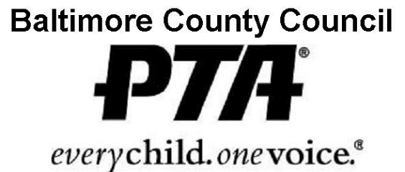

“Back to Basics”

FALL RECEPTION AND WORKSHOPS

Thursday, October 27, 2016
Pikesville High School
7621 Labyrinth Road
Baltimore, MD 21208

6:00 pm – 9:30 pm

Event Highlights

Reception and Exhibits 6:00 pm - 7:00 pm: Dine on lite fare and desserts as you visit with various BCPS personnel, special guests, and exhibitors representing education, health, safety, and cultural arts nonprofit organizations.

Meeting 7:00 pm: Attend the PTA Council General Membership Meeting.

Workshops, 7:45 pm: Select from a variety of topics.

Special Guest Information
RSVP: Marilyn Ryan, 410-665-4450 or email jpryan7@juno.com
Special Guest Registration: Upon arrival please report to the guest registration desk
Introductions: At approx 6:50 pm proceed to the auditorium; front row reserved for guests

WORKSHOPS
SESSION I: 7:45 pm SESSION II: 8:40 pm
Mike Gimbel/Maryland addiction Recovery Center
Discussion on the current drug scene in Baltimore County and information on resources for parents
PTA Advocacy;
Let Your Voice Be Heard
All board members are welcome.
All advocacy chairs should attend

PTA Websites, e-communication and Social Media
All board members are welcome.

Parents University:
What is Parents University? What programs are available to assist you?

PTA Bylaws/Secretary
Understanding and Reviewing Your Bylaws and the Role and responsibility of the Secretary

Committees:
Running a PTA Committee
All board members are welcome.
All committee chairs should attend.

Increasing Your PTA’s Outreach
Are you utilizing all of the parents in your PTA/School

SPECIAL 90 MINUTE SESSIONS: begins at 7:45 pm
President Forum and Leadership discussion
Open discussion about running a PTA

Treasurer’s Workshop
Learn the fundamentals of managing financial matters for your PTA/PTSA. Review procedures for creating a budget, preparing monthly reports, keeping accurate records and auditing financial records. Receive answers to your money management and incorporation questions. Treasurers

“BACK TO BASICS”
All PTA leaders, school personnel, and community members
are encouraged to attend this extremely informative event.

Early Bird Registration Fee: $10.00 per person if received by 10/21/16
Late Registration Fee: $12.00 per person;

PTA/PTSA Name

1. Name Phone
Email Position
Workshop ___________________________

2. Name Phone
Email Position
Workshop ___________________________

3. Name Phone
Email Position
Workshop ___________________________

4. Name Phone
Email Position
Workshop ___________________________
For additional registrants attach another form. Keep a copy of form(s) for your records.
Early Bird Registration must be received by October 24, 2016
Make checks payable to: PTA Council of Baltimore County, Inc.

Send Registration form(s) & payment to: Marilyn Ryan
Contact: 410-665-4450 or 3014 Sixth Avenue
bylaws@bcptacouncil.org Baltimore, MD 21234

FALL RECEPTION AND

WORKSHOPS REGISTRATION

OCT 27

Deliver to the PTA President

